**Code:**

**#Code1**

**file1 = open("myfile.txt", "w")**

**L = ["This is Calcutta \n", "This is China \n", "This is France"]**

**file1.writelines(L)**

**file1.close()**

**# Append-adds at last**

**file1 = open("myfile.txt", "a") # append mode**

**file1.write("Today \n")**

**file1.close()**

**file1 = open("myfile.txt", "r")**

**print("Output of Readlines after appending")**

**print(file1.read())**

**print()**

**file1.close()**

**# Write-Overwrites**

**file1 = open("myfile.txt", "w")**

**# write mode**

**file1.write("Tomorrow \n")**

**file1.close()**

**file1 = open("myfile.txt", "r")**

**print("Output of Readlines after writing")**

**print(file1.read())**

**print()**

**file1.close()**

**#Code2**

**file = open("myfile.txt","r")**

**print("The contents of the file: ")**

**print(file.read())**

**file.close()**

**file = open("myfile.txt","r")**

**lines = 0**

**words = 0**

**symbols = 0**

**for line in file:**

**lines += 1**

**words += len(line.split())**

**symbols += len(line.strip('\n'))**

**print("\nDetails")**

**print("Lines:", lines)**

**print("Words:", words)**

**print("Symbols:", symbols)**

**file.close()**

**#Code3**

**# import OS module**

**import os**

**# Get the list of all files and directories**

**path = "C://Users//USER//Desktop//Sufi Folder"**

**dir_list = os.listdir(path)**

**print("Files and directories in '", path, "' :")**

**# prints all files**

**print(dir_list)**

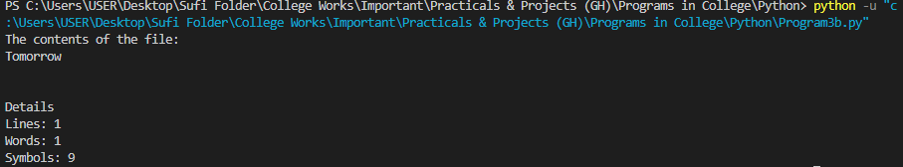**Outputs:**

